**SQL Queries**

**KPI**

1. **Total Revenue**

**select sum(total_price) as Total_Revenue from pizza_sales;**

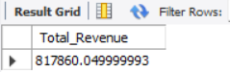

1. **Average order values**

**select sum(total_price)/max(order_id) as Average_order_value from pizza_sales;**

**select sum(total_price)/count(distinct order_id) as "Average order value" from pizza_sales;**

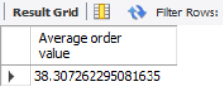

1. **Total pizza sold**

**select sum(quantity) as "Total Pizza Sold" from pizza_sales;**

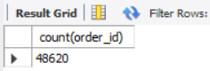

1. **Total Order**

**select count(distinct order_id) as "Total Order" from pizza_sales;**

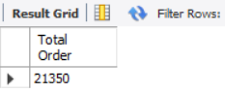

1. **Average Pizza Per order**

**select sum(quantity)/count(distinct order_id) as "Average pizza per order" from pizza_sales;**

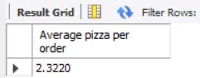

1. **Daily trend for Total Order**

select

dayname(str_to_date(order_date, '%d-%m-%Y')) as Day,

count(distinct order_id) as total_order

from Pizza_sales

group by day

order by field(day, 'Monday', 'Tuesday', 'Wednesday', 'Thrusday', 'Friday', 'Saturday', 'Sunday');

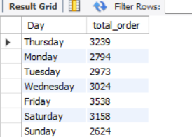

1. **% of sales by pizza category**

**select distinct Pizza_category, cast(sum(total_price) as dec(10,2)) as Total_sales,**

**cast(sum(total_price) * 100 / (select sum(total_price) from pizza_sales) as dec (10,2))**

**as "Percent sales by pizza category"**

**from pizza_sales**

**group by pizza_category;**

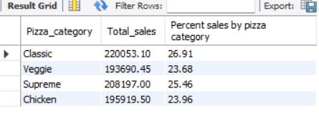

1. **% of sales by Pizza size**

**select distinct pizza_size, cast(sum(total_price) as dec(10, 2)) as "Total sales",**

**cast(sum(total_price)*100/ (select sum(total_price) from pizza_sales)as dec(10,2))**

**as "percentage of sales by pizza size"**

**from pizza_sales**

**group by pizza_size;**

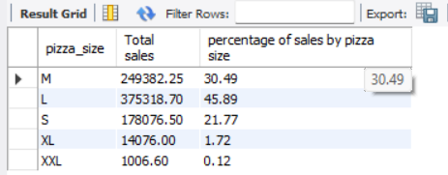

1. **Total pizza sold by pizza category**

**select distinct pizza_category, sum(quantity) as "Total quantity sold"**

**from pizza_sales**

**group by pizza_category;**

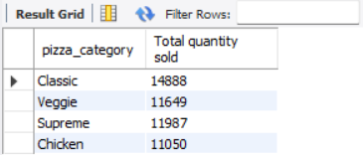

1. **Top five Pizza by revenue**

**select pizza_name, sum(total_price) as Total_Sales from pizza_sales**

**group by pizza_name**

**Order by total_Sales desc;**

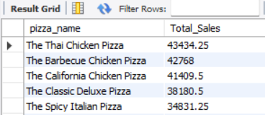

1. **Bottom 5 Pizza by revenue**

**select distinct Pizza_name, sum(total_price) as Total_Sales**

**from pizza_sales**

**group by pizza_name**

**order by Total_sales asc;**

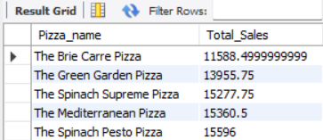

1. **Top 5 pizza by quantity**

**select distinct Pizza_name, sum(quantity) as Quantity**

**from pizza_sales**

**group by pizza_name**

**order by Quantity desc;**

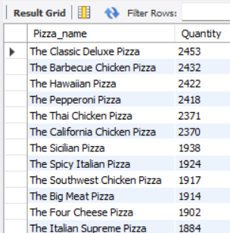

1. **Bottom 5 Pizza by quantity**

**Select Pizza_name, sum(Quantity) as Quantity**

**from pizza_sales**

**group by pizza_name**

**order by quantity asc;**

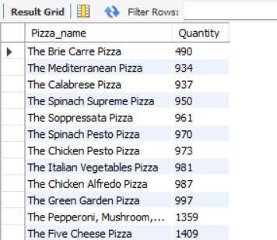

1. **Top five pizza by total order**

**select pizza_name, count(distinct order_id) total_order**

**from pizza_sales**

**group by pizza_name**

**order by total_order desc;**

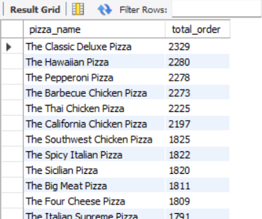

1. **Bottom 5 pizza by total order**

**select distinct pizza_name, count(distinct order_id) as total_order**

**from pizza_sales**

**group by pizza_name**

**order by total_order asc;**

